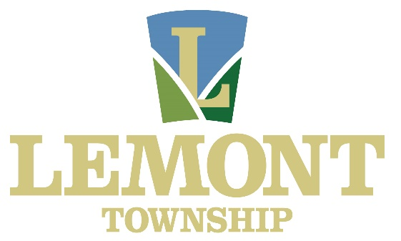

Employment Opportunities | January 2025

Lemont Township does not have any job openings currently. Check back for updates- any job opportunities will be posted here!

